|  |  |
| --- | --- |
| Name | M.Faizan Azam, Muhammad Asad |
| Reg # | 2019-EE-381,2019-EE-383 |

**Experiment # 11**

**555 timer in A stablemode and as a Voltage Control Oscillator**

***Apparatus:***

555 timer, Capacitors, Resistors, DMM, CRO, Function Generator, Jumpers, Connecting wires, DC source, bread board

***The Astable 555 Timer***

The 555 IC can be used to create a free running astable oscillator to continuously produce square wave pulses.

Also the single timing resistor of the previous monostable multivibrator circuit has been split into two separate resistors, R1 and R2 with their junction connected to the discharge input (pin 7) as shown below.

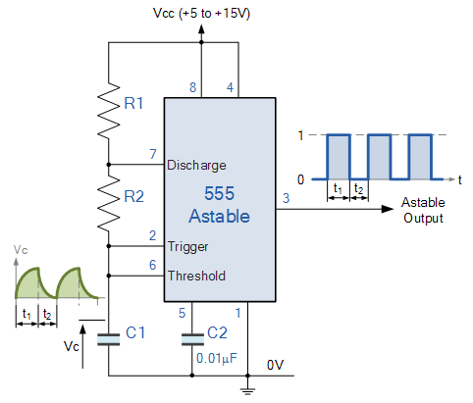

In the 555 Oscillator circuit above, pin 2 and pin 6 are connected together allowing the circuit to re-trigger itself on each and every cycle allowing it to operate as a free running oscillator. During each cycle capacitor, C charges up through both timing resistors, R1 and R2 but discharges itself only through resistor, R2 as the other side of R2 is connected to the discharge terminal, pin 7.

Then the capacitor charges up to 2/3Vcc (the upper comparator limit) which is determined by the 0.693(R1+R2)C combination and discharges itself down to 1/3Vcc (the lower comparator limit) determined by the 0.693(R2*C) combination. This results in an output waveform whose voltage level is approximately equal to Vcc – 1.5V and whose output “ON” and “OFF” time periods are determined by the capacitor and resistors combinations.

***555 Timer as Voltage Control Oscillator***

Pin 5 terminal is voltage control terminal and its function is to control the threshold and trigger levels. Normally, the control voltage is ++2/3VCC because of the internal voltage divider. However, an external voltage can be applied to this terminal directly or through a pot, as illustrated in figure, and by adjusting the pot, control voltage can be varied.

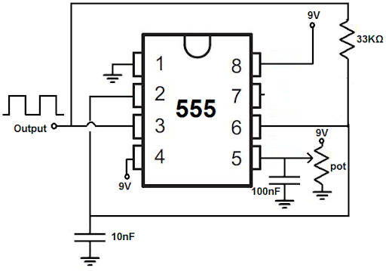

**Astable mode:**

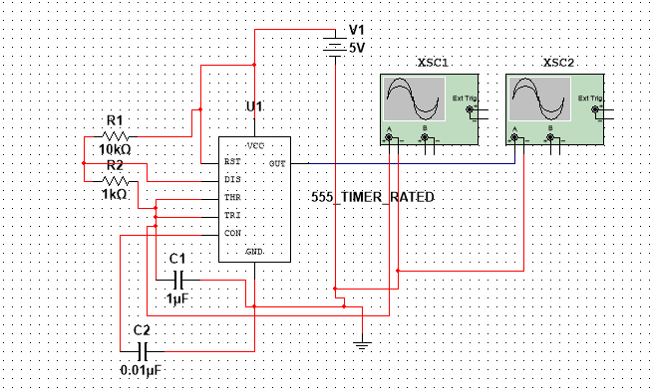

***Output Waveform:***

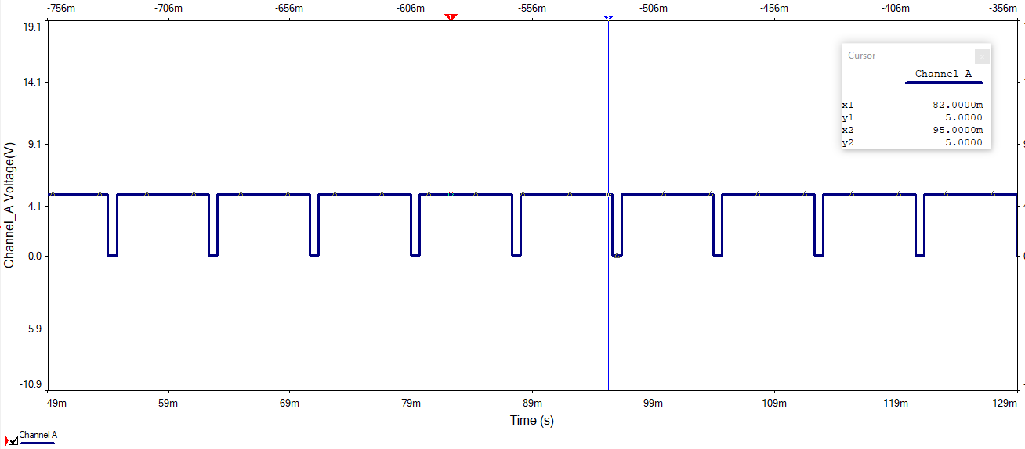

**Voltage Control oscillator:**

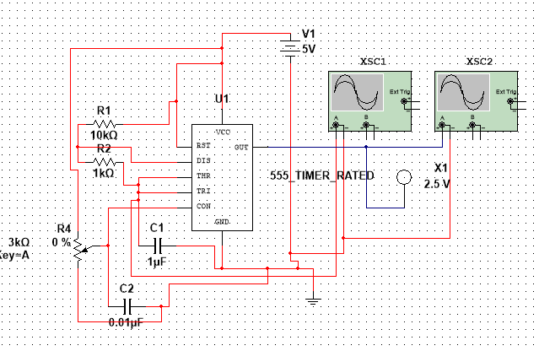

***Output Waveform:***

